Assignment - 1
- Group Members:
Students’ Name | Student ID
- Sabit Naim | 041155239
- Nibir Nandi Dibbo | 041124380
- Vasukumar Patel | 041153940

- Our Chosen scenario:
- We have chosen Scenario 3: Dead Prime Minister High School for our group assignment.

- Business Abstract:
DPMHS is a new school under construction. The new principal, Jesse Strictman has been given the freedom to configure the school’s information system. In the school, the student will enroll in one or many course. And they must have one or many legal guardians. The student’s and the legal guardian’s addresses are stored in the system, they can be the same or different. The student must take standardized test and will receive grade. The student may participate in extra-curricular activities and may have post high school plan. When a student commits misconduct, a disciplinary action must be taken by the school and this misconduct will be recorded. If a student drops out or is transferred or graduates, their information is stored in the system. In this system, we don’t consider the fees of the school.

- A list of entities and attributes with a short description:

- STUDENT – This entity is used to keep track of the school’s students.

Attributes – StudentID, StudentName, Gender, Birthdate, DateEnrolled, LegalGuardians, DateTransfered, DateGraduated, DateDroppedOut.

- EXTRACURRICULAR_ACTIVITIES – this entity tracks the number of extracurricular activities played by a student.

Attributes – StudentName, AcademicYear, TeamName, Offices.

- ENROLLMENTS – this entity represents a student's registration in an academic institution for a specific year or term.

Attributes - EnrollmentID, HomeroomTeacher, HomeroomLocation, AcademicYear, OverallGPA.

- COURSES - this entity keeps track of the students’ course’s details.

Attributes – CourseID, CourseName, CourseLocation.

- GRADES - this entity tracks the students’ grades periodically and this is a weak entity.

Attributes – GPAPeriodic.

- TESTING_RESULT - this entity keeps tracking the test details and results.

Attributes - TestCode, TestName, TestDate, TestResult, StudentName.

- ADDRESSES - this entity keeps track of the student and the guardians’ addresses.

Attributes – AddressID, Street, City, PostalCode.

- LEGAL_GUARDIANS - this entity keeps track of the details of a student’s legal guardians.

Attributes – GuardianID, Name, ChildrenNames, Homephone, Gender, Birthdate.

- DISCIPLINARY_ACTION – this entity keeps track of the disciplinary action that has been taken by the school.

Attributes – RecordID, IncidentType, IncidentDate, ActionTaken, StudentName.

- POST_HIGH_SCHOOL_PLAN – this entity keeps tracking students’ plans after their schooling and this is a weak entity.

Attributes – EducationChosen, AppliedTo, ApplicationDate, ApplicationResult.

- Business Rules:
- A student may participate in one or more extracurricular activities.
An extracurricular activity must have one student.

- A student must have one or more enrollments.
Enrollments must have one or more students.

- Enrollments must have one course.
Courses must have one or more enrollments.

- Courses must have one or many grades.
Grades must have one course.

- A student must have one or many testing result.
A testing result must have one or many students.

- A student must have one or many addresses.
Addresses must have one student.

- A student must have one or more legal guardians.
Legal guardians must have one or more students.

- Legal guardians must have one or many addresses.
Addresses must have one legal guardian.

- A student may have one or more disciplinary action.
Disciplinary action must have one student.

- A student may have one or more post high school plan.
Post high school plan must have one student.

- A list of unknowns:
- StudentID
- EnrollmentID
- CourseID
- TestCode
- AddressID
- GuardianID
- RecordID

- A list of assumptions:
- Assuming addresses is an entity.
- Entity addresses can store values from student and legal guardians.
- A student and their guardian can live at the same address. So, it will not create multiple entries.

- Conceptual diagram:
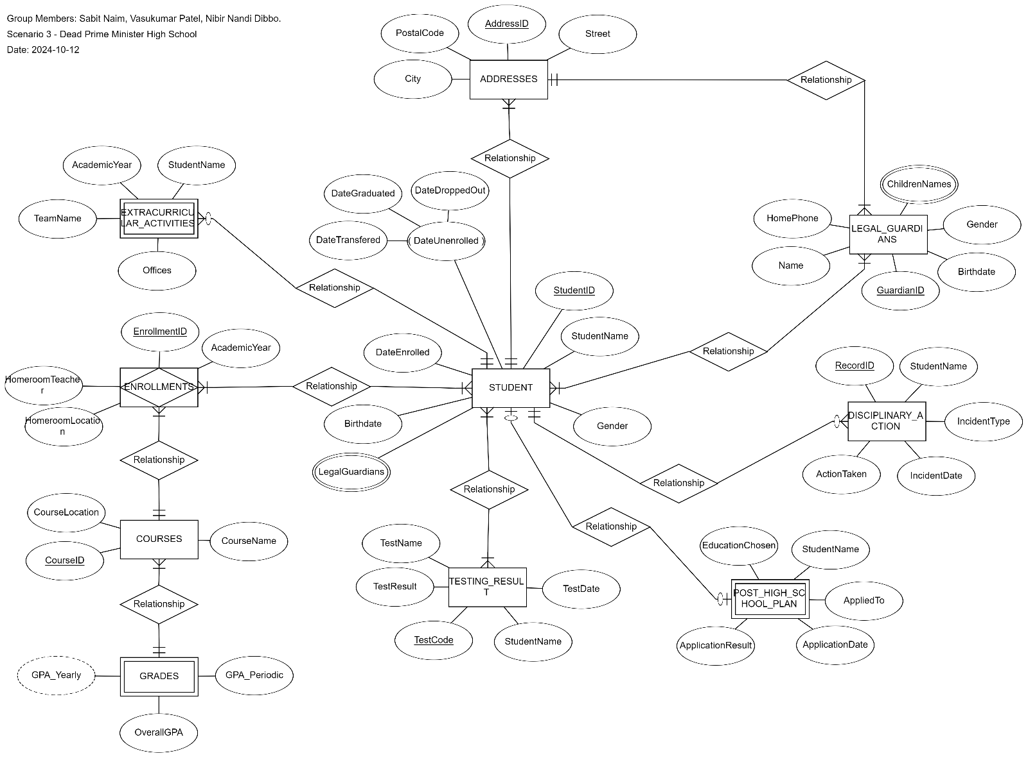

- Physical diagram:
